Introduction

Objectives:

Goals:
- What are the goals of the analysis and why did you choose them?

Research questions:
- What question(s) do you want to answer?

Hypothesis:
- What hypothesis(es) do you have and what is your approach to tackle the problem?

Data Preparation:

Data source:
- What was your data source (e.g., web scraping, corporate data, a standard machine learning data set, open data, etc.)?
- What did you need to do to procure it?
The data source for the analysis is a compilation of medical test results for heart patients from four researchers at medical centres in Budapest, Switzerland, and the United States. The combined dataset was assembled and made publicly available on the dataset repository Kaggle by David Aha.
The dataset was downloaded from Kaggle in tabular format, and imported into Python using the Pandas package. It contained records for 303 anonymous patients, consisting of both medical test results such as blood cholesterol and heart rate, and limited demographic information such as age and sex.

Data quality:
- How good was the data quality?

Data preparation
- What tools or code did you need to use to prepare it for analysis?
- What challenges did you face?

Analysis:

Initial descriptive analysis
age | Patient’s age in years
sex | Patient’s sex
cp | Chest pain type (4 values)
trestbps | Resting blood pressure
chol | Serum cholestoral in mg/dl
Fbs | Fasting blood sugar > 120 mg/dl
restecg | Resting electrocardiographic results (values 0,1,2)
thalach | Maximum heart rate achieved
exang | Exercise induced angina (yes or no)
oldpeak | ST depression induced by exercise relative to rest ('ST' relates to positions on the ECG plot) ¹
slope | The slope of the peak exercise ST segment in the ECG plot
ca | Number of major vessels (0-3) colored by fluorosopy
thal | Presence of a blood disorder called thalassemia (normal, fixed defect, or reversible defect)

Feature selection

Selection of classifier and hyperparameter tuning

Fitting model

Testing model
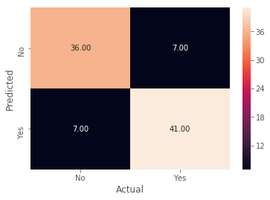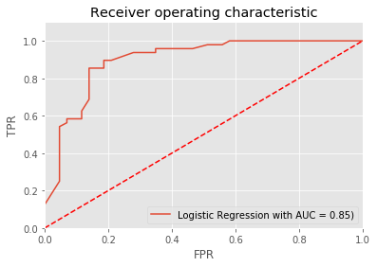

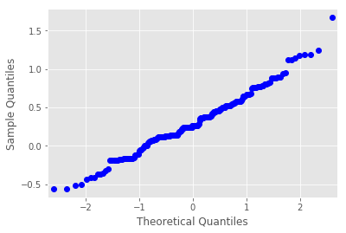
The Area under the curve of our model was 0.87. An AUC score of 0.5 could be attained through just guessing, and an AUC score of 1.0 is a perfect classifier. This means that our classifier was quite successful at calculating whether a given patient had heart disease or not.
A next step is to attempt to reduce false negatives, because it is very important that our model does not tell a patient they do not have heart disease if in reality they do. Such a result may be fatal to the patient.

Conclusions:
- What did you learn about your data set?

Summary paper outline:
- Data source: What is the nature of the data you chose? Why is it interesting?
- Analysis: What were the challenges? How did you overcome them?
- Conclusions: What did you learn about your dataset?

